# Unit 2: Atomic Structure and Bonding

# <H1>Unit Essential Question

* 1. How does the organization of atoms in a Periodic Table help us predict their properties?
  2. How do atoms combine to make all the different compounds that exist?

# <H1>Unit Big Idea: The Unseen World of Atoms.

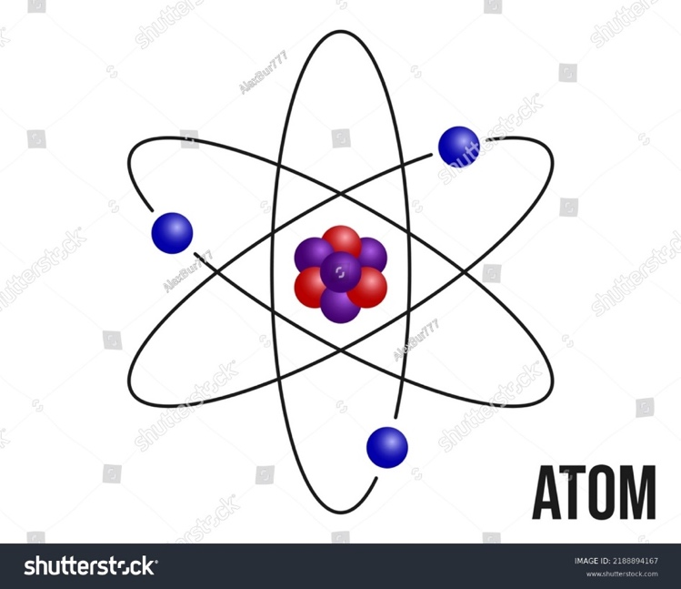Atoms are the architects of matter, invisible yet omnipresent. By unlocking the mysteries of atomic structure and bonding, we delve into the nature of everything around us. Understanding atomic models, electron configurations, and bonding theories reveals the patterns that govern chemical interactions and offers insights into the structure and behavior of matter itself. The periodic table becomes a map guiding us through the intricate and beautiful dance of elements.

# <H1>Unit phenomenon: Danger! Icy Roads

In northern countries, where winter brings extremely cold weather, streets and roads are often covered in ice and snow. This creates hazardous conditions for both pedestrians and drivers. Pedestrians can slip and fall, risking injury, while cars may skid on the icy surfaces, potentially causing accidents. To reduce these dangers, road salt is spread on icy streets to help melt the ice and snow. As the salt comes into contact with the ice, ice and snow seem to vanish. Metal street signs and lampposts are also exposed to the same ice and snow, but they do not vanish.

# <H1>Last Time, This Time, Next Time

|  |  |
| --- | --- |
| Last time | Everything in the universe is composed of tiny, indestructible particles, called atoms. Atoms are responsible for the physical and chemical properties of all objects.  Atoms have mass and are electrically neutral. |
| This time | Protons and neutrons at the atom’s nucleus are responsible for the atom’s mass.  Protons have a positive charge while neutrons have no charge.  The atom’s negative charge resides in the electrons, located outside of the nucleus in energy levels or orbits.  The elements are organized in a Periodic Table to highlight properties and trends.  Atoms can lose or gain electrons. When this happens, atoms are no longer neutral and are called ions.  Atoms that have lost electrons to become ions with positive charge are called cations.  Atoms that have gained electrons to become ions with negative charge are called anions.  Since opposite charges attract, cations and anions strongly attract each other and form a bond called *ionic bond*.  Atoms can also combine by sharing electrons in other types of chemical bonds.  In covalent bonds, electrons are usually shared and localized between 2 atoms.  In metallic bonds, electrons are shared and delocalized among a network of positively charged metal ions. |
| Next time | Substances react in different ways forming other substances.  Substances react in different proportions to form different substances. |

# <H1>Unit Stem Task

Explain how the atomic structure impact on chemical bonding and influence the properties of substances we encounter daily life, such as road salt melting ice or metal street signs resisting changes.

<H1> Unit Overview

|  |  |
| --- | --- |
| **Chapters** | **PE** |
| Chapter 3: Unlocking the Atom | HS-PS1-1, HS-PS1-8 |
| Chapter 4: Electrons in Action | HS-PS1-1, HS-PS4-3 |
| Chapter 5: The Periodic Table and Chemical Trends | HS-PS1-1 |
| Chapter 6: Ionic and Metallic Bonding | HS-PS1-2, HS-PS1-3 |
| Chapter 7: Covalent Bonding | HS-PS1-2, HS-PS1-3, HS-PS1-4 |

# <H1>Study Strategies

|  |  |
| --- | --- |
| **Strategy** | **Advantages** |
| Study for short periods of time (about 20 to 25 min.) with a 5 min. break in between. Ideally, take a walk during the break. | Self-awareness of your attention span and concentration limits to better understand your own learning needs and preferences.  Self-manage your time, set goals, avoid procrastination, clear the mind and refresh your body. |
| Work with a classmate using flashcards. Take turns to draw a card and answer the question, explain the concept, or provides an example. Conduct a short discussion with the peer. | Self-awareness of your own understanding and identify areas where you need further clarification.  Self-manage the organization of your study.  Social Awareness by practicing active listening.  Relationship skills by developing communication and collaboration skills. |

# Chapter 6: Ionic and Metallic Bonding

# <H1>Chapter Essential Questions

1. Why does salt dissolve in water?
2. Why do metals not dissolve in water?

# <H1>Chapter Big Idea

Atoms interact and bond to form more complex structures. Ionic and metallic bonds are two key ways that atoms combine to create stable compounds and materials with distinct properties. Ionic bonding occurs when atoms transfer electrons, while metallic bonding involves a sea of delocalized electrons that hold metal atoms together. These bonding explain the behavior of substances in everyday life, from salts to metals.

# <H1>Chapter Phenomenon: Salt vs. Metal, Why Does Water Treats Them Differently?

When road salt is spread on icy and snowy streets, the ice and snow melt and the salt dissolves in the water. Street signs and lampposts are made of metal, but they do not melt the snow or dissolve in water. Instead, they remain intact, showing no immediate signs of rust or corrosion. Why do salt and metal behave so differently with water?

# <H1>Chapter STEM Task:

Create a model to show the ionic bonds in NaCl and the metallic bonds in a piece of iron. Use the model to explain how ionic bonds break apart in water, allowing ions to dissolve while metals behave differently.

# <H1>Chapter overview

Lesson 1: Formation and Properties of Ions

Lesson 2: Ionic Bonding and Compound Formation

Lesson 3: Naming and Formulas of Ionic Compounds

Lesson 4: Metallic Bonding and Metal Characteristics

# Lesson 2: Ionic Bonding and Compound Formation

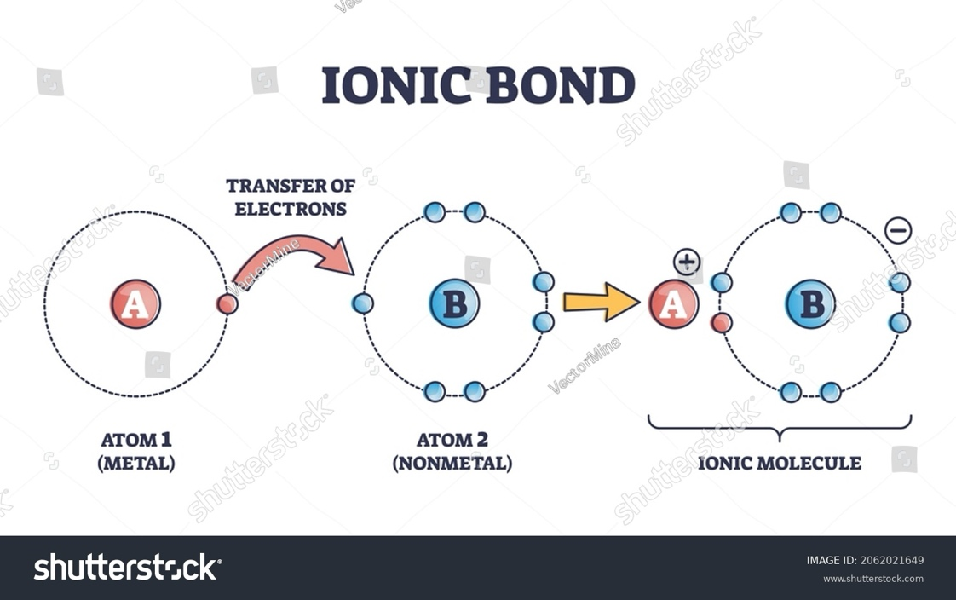

Figure 2.x showing outermost shell of atoms

# <H1> Essential Questions

How do ionic bonds form, and what properties do ionic compounds exhibit?

# <H1>Big Idea

Ionic bonding occurs when a cation and an anion are held together in place by electrostatic attractions. This type of interaction confers to ionic compounds specific properties such a tendency to dissolve in water.

# <H1>Lesson Phenomenon

In northern countries, people throw salt on ice and snow to melt them and reduce the risk of slippery streets and roads. The salt seems to disappear in the newly formed liquid water. Why does salt seem to "disappear" into the ice?

# <H1> Key Vocabulary

Ionic bond: a type of chemical bond formed by the electrostatic attraction between a cation and an anion.

Lattice energy: the energy released when an ionic compound is formed from its constituents’ ions in gaseous state.

# <H1> Lesson Objectives

By the end of the lesson, the I will be able to:

* Define ionic bonding and illustrate its formation using diagrams for simple examples such as NaCl or MgO.
* Identify the properties of ionic compounds and analyze their real-world applications.

# <H1> What happens to salt if it is spread over icy and snowy streets?

To explain this, we need to first look at why atoms bond to form compounds and then how they do it.

## <H2>Why do atoms bond?

**Recall** from the previous lesson that atoms become more stable when they acquire noble gas electron configuration; that is when their outermost shell of electrons is complete. For most atoms, that means eight electrons (*s2 p6* configuration) in the outermost energy level, thus the name of the rule, *the Octet Rule*. However, the 3 atoms with the lowest atomic number (H, Li, and Be) do not have *p* orbitals readily accessible, so they complete their outermost shell with only 2 electrons (*s2* configuration).

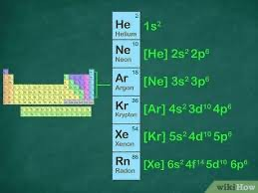

**Commented [M9]:** Sample image

Figure 2.x: Electron configuration of noble gases

## <H2> How can atoms attain noble gas electron configuration?

They do so by gaining, losing, or sharing electrons, whichever process is more energetically favorable. The sharing of electrons will be studied in the next chapter. In this lesson, the focus is on gaining or losing electrons.

For some atoms, gaining an electron to acquire noble gas configuration is energetically favorable. These atoms are located in Periodic Table groups on the right, near to the noble gases; they are non-metals and have high electron affinity. That is, they release large amounts of energy when they gain electrons in the gas phase and form an ion with a negative charge due to the extra electrons. **Recall** from the previous lesson that ions with negative charges are called anion. This anion has the electron configuration of the closest noble gas, the noble gas with a higher atomic number.

For some other atoms, losing an electron to acquire noble gas configuration will require less energy than gaining or sharing electrons. These atoms are located in groups to the left and center of the Periodic Table. They mostly represent metals and are elements with low ionization energy. Little energy is required to remove electrons from these atoms in the gas phase and form a positive ion, or cation. For example, UV radiation (sunlight) can easily convert an *Na* atom into a *Na+* cation. Cations have the electron configuration of the closet noble gas, the noble gas from the previous period, with a lower atomic number.

## <H2>What could happen when metals are in contact with non-metal?

Most low ionization energy metals in daily life (Al, Zn, Cu, Cr, Ni, Pb, Sn) tend to have a protective layer of oxide that prevents them from reacting with air, water, and other substances in their environment. However, if the metal is exposed, with just a little energy it releases electrons and becomes a cation. Non-metals (such as O, F, Cl) could readily capture the electrons released from the metal and form an anion while releasing energy. That energy can be promptly used by other metal atoms to lose electrons reinitiating the cycle. Thus, when metals and non-metals come into contact, many cations and anions are formed.

## <H2>What happens when cations and anions are in proximity?

Opposite charges attract! Cations and anions have opposite charges, and they are attracted to each other by **electrostatic forces**. The attraction is so strong that when they are close enough in gaseous state, they release energy and form a solid ionic crystal in which the ions are held together by *ionic bonds*.

In some way, ionic compounds form by the transfer of electrons from the cation to the anion so that both achieve stable electron configurations, often following the octet rule. Recall the exceptions to the octet rule: Li and Be attain noble gas configuration similar to He, their closest noble gas, by losing an electron and remaining with 2, rather than 8, electrons in their outer shell. The H atom can also lose its electron but in this case, it remains with no electrons, a naked proton. Lastly, H can also gain an electron an attain He noble gas configuration with 2 electrons in its outer shell.

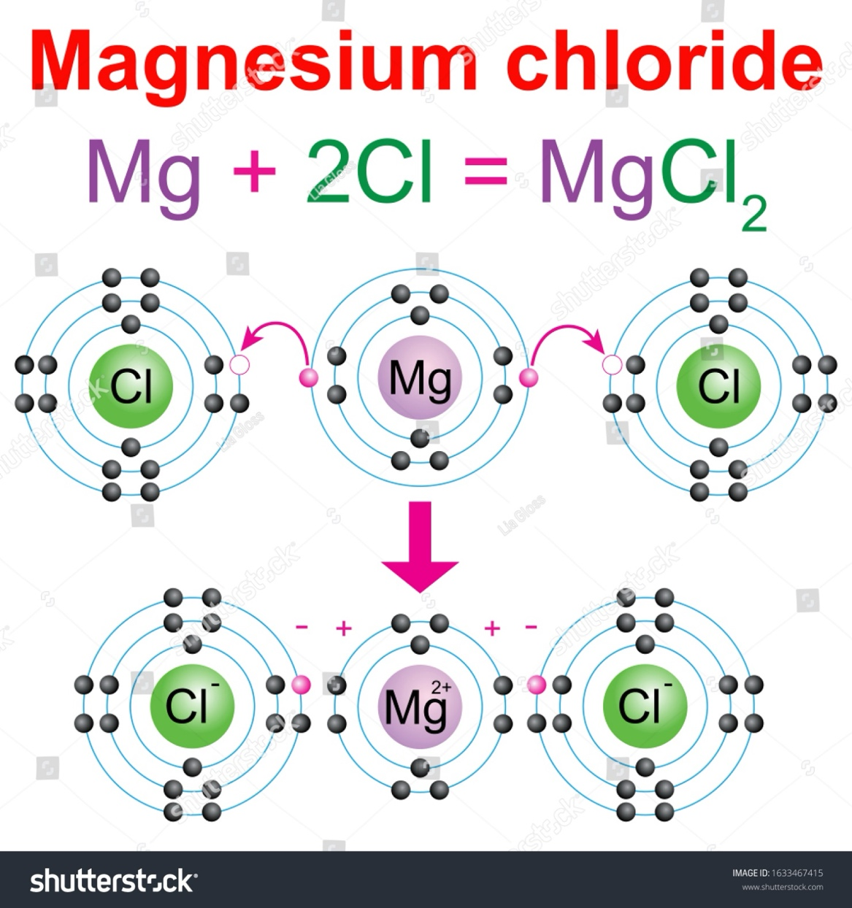

Figure 2.x. Formation of Magnesium Chloride

## <H2>How are ionic compounds held together?

Ionic compounds form crystals or crystalline solids, which are regular, repeating three- dimensional arrangement of ions. Crystals are formed by large numbers of ions; they have a formula (for example *NaCl*) but they do not form molecules because they form an extended structure. This structure is held together by lattice energy.

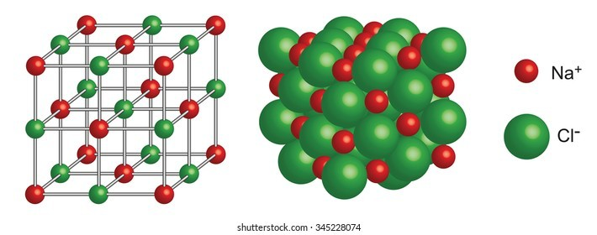

**Commented [LM11]:** Sample image

Figure 2.x. Structure of Sodium Chloride

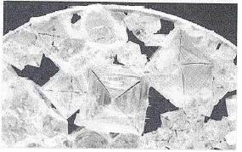

Figure 2.x: The regular arrangement of ions in salt, creating a pattern seen in the crystals

## <H2>Progress Check

Explain how positive and negative ions combine to form an ionic bond.

# <H1>Lab Experiment: Formation of Ionic Compounds

Let’s observe how these ionic crystals are formed!

Materials:

* NaCl solution (0.1 M)
* AgNO3 solution (0.1 M)
* Test Tubes
* Pipettes
* Beakers
* Stirring Rod

Procedure:

1. Pour 10 mL of NaCl solution into a test tube.
2. Use a pipette to add AgNO₃ solution drop by drop to the test tube.
3. Observe what happens and record your observations in your lab notes.

## <H2> Explain your observations

1. Reflect on the possible nature of the white precipitate based on the ions present in the solution.
2. Why do you think the while precipitate formed? Discuss with classmates.

# <H1>Properties of Ionic Compounds

Ionic compounds have several distinctive properties due to the nature of the strong electrostatic forces that form the ionic bonds. Reflect on the facts and examples of the first column of the table to decide on the property listed on the last column.

|  |  |
| --- | --- |
| **Facts and examples** | **Property (circle the correct answer)** |
| 1. The strong electrostatic forces between cations and anions imply that large amounts of energy are required to move ions apart. For example, NaCl has a melting point of about 801°C and a boiling point of 1,413°C. | Boiling and melting point: high or low? |
| 1. Ionic bonds are very strong, requiring significant energy to break. The strong electrostatic forces between oppositely charged ions create resistant to deformation or scratch three-dimensional structure that is hard to overcome. | Hard or flexible? |
| 1. Cations and anions are rigidly held in place in an ordered crystal structure; they cannot deform or rearrange. When subject to mechanical stress, like being hit or bent, they shatter or break easily. | Brittle or malleable? |
| 1. As solids, cations and anions are held in place in the crystal structure, they do not move. | **In solid state**, conductor or insulator of electricity? |
| 1. When melted, the ions can move. | **In liquid state**, conductor or insulator of electricity? |

1. **Solubility in water:** The balance between lattice energy and hydration energy determines in the ionic compound dissolves.
   * + Lattice energy is the energy required to break the ionic bonds holding the ions together in the solid crystal. This energy is always positive; it needs to be absorbed by the ionic compound.
     + Hydration energy is the energy released when ions from an ionic compound interact with water molecules and become surrounded by them. Water molecules have a partial positive end and a partial negative end. When an ionic compound is placed in water, the water molecules surround the individual ions. The positive ends of water molecules attract the negative ions in the compound, and the negative ends of water molecules attract the positive ions. This process is releases energy as they stabilize the ions in solution.

If this release of energy is greater than or equal to the lattice energy, the ions break apart from the crystal and dissolve in water.

The energy balance between hydration energy and lattice energy is influenced by the strength of the ionic bonds in the crystal which relates to the charges and sizes of the ions.

* + Highly charged ions (for example *O2−* and *Al 3+)* have stronger electrostatic attractions, leading to higher lattice energy and lower tendency to dissolve.
  + Small sized ions (for example *F−* and *Li +)* can pack more closely together in the crystal lattice, resulting in stronger attractions and higher lattice energy. Therefore, compounds with smaller ions are also generally less soluble.

## <H2>Progress Check

Apply the concept of balance between hydration energy and lattice energy to explain why NaCl and AgNO3 were able to stay dissolved in water while AgCl precipitated.

# <H1>Critical Thinking

The Questioneer Icon

Reflect on the following prompts to think critically about the content and come up with meaningful questions for inquiry about **ionic bonding** and **ion formation**.

1. Different atoms form different ions.
2. Some atoms gain electrons. Where do those electrons come from?
3. Ionic compounds do not form molecules.
4. Due to the electrostatic forces that hold the ions in place, ionic compounds are not volatile, ductile, or malleable.

# <H1>Quiz

1. Which of these elements form cations and which form anions: Sc, F, Mg, P, Cr, Fe?
2. What type of atoms will more easily lose electrons: those with few valence electrons or those with a larger number of valence electrons? Debate your ideas with a classmate and give examples. You may look up the ionization energies and electron affinity values in tables for atoms with different numbers of valence electrons.
3. Debate ideas with a classmate: Among the halogens, group 17 of the Periodic Table, what atom will release more energy when forming an anion, F or I? You may look up the electron affinity values in tables and think of the atom size to answer this question.
4. Why is solid NaCl a bad conductor of electricity?
5. Which compound has higher lattice energy: MgOand NaCl? Why?
6. Explain the Octet rule and describe one of its major advantages and one of its limitations.
7. Explain why salt conducts electricity when dissolved in water but not in its solid form.
8. In pairs or small groups, create a diagram showing the ionic bonding between calcium (Ca) and chlorine (Cl) to form calcium chloride (CaCl₂). Exchange diagrams with other groups and provide feedback.
9. Which of the following best describes the structure of an ionic compound?
   * 1. Clearly identifiable individual molecules.
     2. An alternating positive and negative ion extended structure.
     3. Free-flowing atoms that move in a gas-like state.
     4. Electrons moving freely between atoms.
10. What property of ionic compounds allows them to conduct electricity when dissolved in water?
11. Their ability to form molecules.
12. The presence of free ions that move and carry charge.
13. Their high melting points.
14. Their ability to form crystal lattices.

# <H1> Beyond the Lesson (Extend)

**Ionic Compounds in Everyday Life:** Explore the chemical composition, properties, applications in everyday life, safety and environmental impact of everyday products that contain ionic compounds, such as table salt (NaCl), toothpaste (which contains NaF), calcium carbonate, potassium nitrate, or baking soda (sodium bicarbonate, NaHCO₃). Use reliable resources to research and create presentations on how these compounds are used in different industries (e.g., food preservation, cleaning products, medical treatments).

# Chapter: Wrap-Up

# <H1> Summary

* When atoms or molecules gain or lose electrons, they form ions that have a net positive or negative charge. When an atom loses electrons, it becomes a positively charged ion, called a cation. Conversely, when an atom gains electron, it becomes a negatively charged ion, known as an anion.
* The octet rule is a chemical principle that states that atoms tend to gain, lose, or share electrons to attain a stable noble gas electronic configuration, typically with eight electrons in their outermost shell.
* Ionic compounds are chemical compounds formed through the electrostatic attraction between positively charged ions (cations) and negatively charged ions (anions). They have a formula but do not form molecules but rather extended crystalline structures.
* Ionic compounds have several distinctive properties due to the nature of the ionic bonds such as high boiling and melting points, they are hard and brittle. Depending on ion charge and size they may dissolve in water.
* MAIN IDEAS FROM LESSONS 3 and 4 IN THE CHAPTER WILL GO HERE

# <H1> Revisiting the Chapter Phenomenon

Why do salt and metal behave so differently with water?

Salt lowers the freezing point of ice and snow so when you add salt to them, they melt and become liquid water. NaCl is a salt formed by not so small ions with low charge (+1 and −1), which confers a low lattice energy. Hence, in the presence of liquid water, the ions get readily hydrated and the salt dissolves.

Metals do not have ions …. To be completed after lessons 3 and 4.

# <H1> Extended STEM Activity

Check and verify if ionic and metallic compounds have indeed high melting points. **Recall Lab Safety Procedures!**

* Equipment: Fisher–Johns (Hot-stage melting point) apparatus with thermometer.
* Samples: Aluminum, NaCl (table salt), baking soda, calcium chloride, and other solid substances of your choice (for example ice, sugar, naphthalene, benzoic acid, salicylic acid, wax).
* Procedure:
  1. Place a sample on a clean microscope slide and then on the Fisher–Johns apparatus.
  2. Turn on the Fisher-Johns apparatus and set the heating rate to a low setting (about 2-5 °C/ min).
  3. Observe the sample through the magnifying lens as the temperature of the hot plate increases.
  4. Record in a table the temperature at which the sample begins to melt.
  5. Compare the melting points of the substances. Which ones are higher?

# <H1>Bring it together!

In this chapter, you set out to learn about ionic and metallic bonds to create a model to represent them and explain how ionic bonds break apart in water, allowing ions to dissolve while metals behave differently. To do that, you had to use your prior knowledge of the structure of the atoms and the Periodic Table to learn about ions in Lesson 1 of this chapter. Then, in lesson 2, Yyu experimented with the solubility of ionic compounds. In lesson 3 …. To be completed once lessons 3 and 4 are written. This helped you …..

# <H1>Chapter journal

# Record the key learning that you take from this chapter on ionic and metallic bonds. You may exchange ideas with a classmate.

# <H1> Formative Questions:

1. MgO is an ionic compound. How do you think it looks at the atomic level? You may draw a labeled diagram.
2. Cu is a metal. How do you think it looks at the atomic level? You may draw a labeled diagram.
3. Explain to a friend who is just starting to learn Chemistry how ionic and metallic bonds differ in structure and properties.
4. How are ionic and metallic compounds used in daily life and in technology?

# Unit Close

## Review Sessions

* 1. How did the Periodic Table come to being and how useful is it?
  2. How does the structure of atoms and the types of bonds they form affect the properties of materials?
  3. What are the trade-offs between using materials that are efficient but harmful to the environment versus finding alternatives that may be less effective?

## <H1>Push Forward

In this unit, your started by learning how atoms are composed and ended by learning how they combine to form cosmpounds. You learned about the atomic models, structure, periodic table and trends, types of bonding, compound formation, and their properties.

Next you will move one step further, by learning how compounds combine and react. Have you ever seen chemical reactions in nature? (here is a hint, you are conducting a chemical reaction right now, as you breath; other examples include rusting of iron, photosynthesis, burning, rooting, or baking). How would you represent these processes? What do they yield?

## 3D End of Unit Assessment

## <H1>Unit Readiness Assessment:

1. Describe an atom. Make sure you refer to subatomic particles, their mass, location, and electric charge.
2. What distinguishes elements, compounds, and mixtures?